9.AIM:-To implement UML diagrams for E-BOOK MANAGEMENT SYSTEM…

1.USECASE DIAGRAM:-

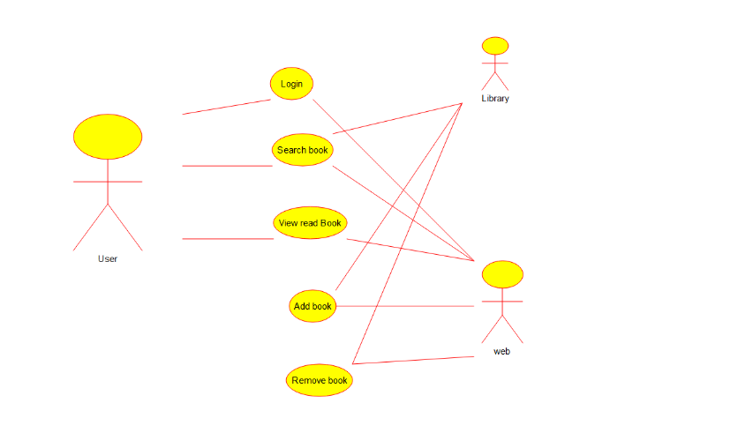

2.CLASS DIAGRAM:-

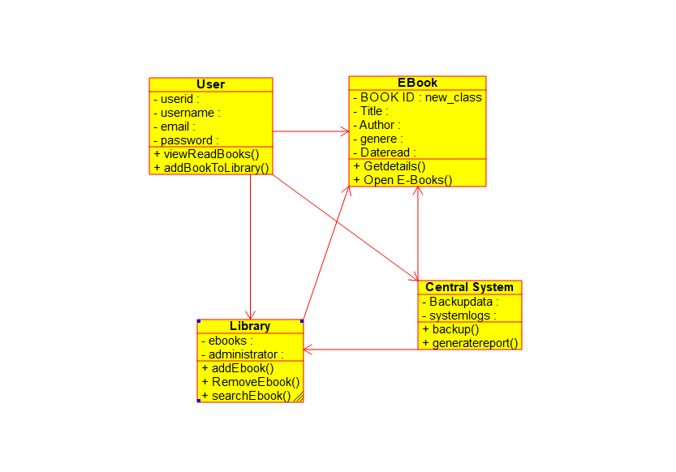

3.ACTIVITY DIAGRAM:-

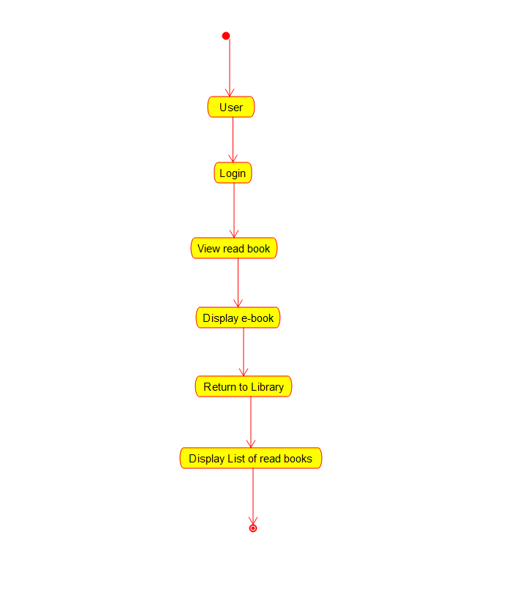

3.CLASS DIAGRAM:-

